Ex. No. : 02 Date:
Register No : 231701007 Name: BADRISH RS

A python program to implement Simple linear regression using Least Square Method

Aim:
To implement Simple Linear Regression using the Least Square Method in Python.

Requirements:
Jupyter Notebook with Python.

PROGRAM:
# Simple Linear Regression using Least Squares Method
import numpy as np
import matplotlib.pyplot as plt
# Input data
x = np.array([1, 2, 3, 4, 5])
y = np.array([2, 4, 5, 4, 5])
n = len(x)
# Calculate sums
sum_x = np.sum(x)
sum_y = np.sum(y)
sum_xy = np.sum(x * y)
sum_x2 = np.sum(x * x)
# Calculate slope (b1) and intercept (b0)
b1 = (n * sum_xy - sum_x * sum_y) / (n * sum_x2 - sum_x**2)
b0 = (sum_y - b1 * sum_x) / n

print("Slope (b1):", b1)
print("Intercept (b0):", b0)

# Predict values
y_pred = b0 + b1 * x
# Plot graph
plt.scatter(x, y)
plt.plot(x, y_pred)
plt.xlabel("X values")
plt.ylabel("Y values")
plt.title("Simple Linear Regression")
plt.show()

Output:
Slope (b1): 0.6
Intercept (b0): 2.2
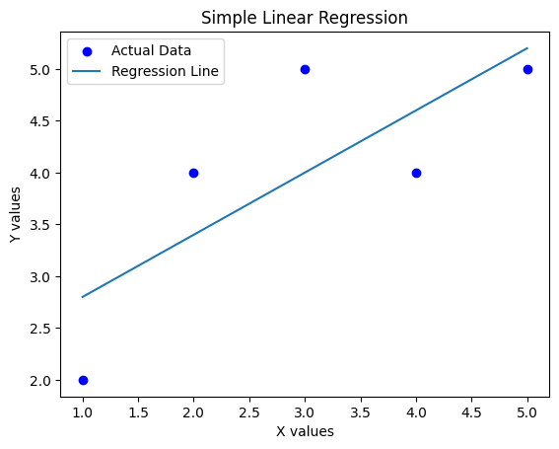

Result:
Thus, the Simple Linear Regression model was successfully implemented using the Least Squares Method.

